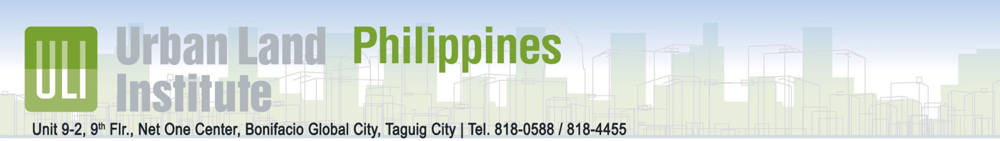
Call for Nominations: ULI Philippines Healthy Places Awards
Taguig City – April 2016 – Urban Land Institute Philippines (ULI) is now accepting nominees for the ULI Building Healthy Places Awards in 4 Categories for Leadership in Healthy Design and Performance (Residential, Commercial, Institutional, Miscellaneous).
Around the world, communities face increasing health challenges related to the built environment. ULI understands the direct link between human health and development, and supports health as a core component of thriving communities. ULI’s Building Healthy Places Initiative leverages the power of ULI’s global networks to shape projects and places in ways that improve the health of people and communities. The initiative focuses on four main areas of impact: awareness; tools; value of healthy places; and commitments.
The ULI Philippines Building Healthy Places Awards recognize outstanding and innovative projects that advance design strategies that focus on the development of environments that promote healthy living in the Philippines. Through the Healthy Places Awards, ULI is working to raise awareness of the direct link between human health and the built environment and the health consequences from land use decisions and development patterns.
Award-winners will have relevance by adding value to the community, promoting healthy life choices and enhancing the environment. Nominees should contribute to significant new ideas and perspectives. Nominees and winners will be recognized at an awards ceremony and reception on July 14, 2016 in Bonifacio Global City.

QUALIFICATIONS
Projects must have been completed between 2012 and 2016.

ULI’s Ten Principles for Building Healthy Places are:
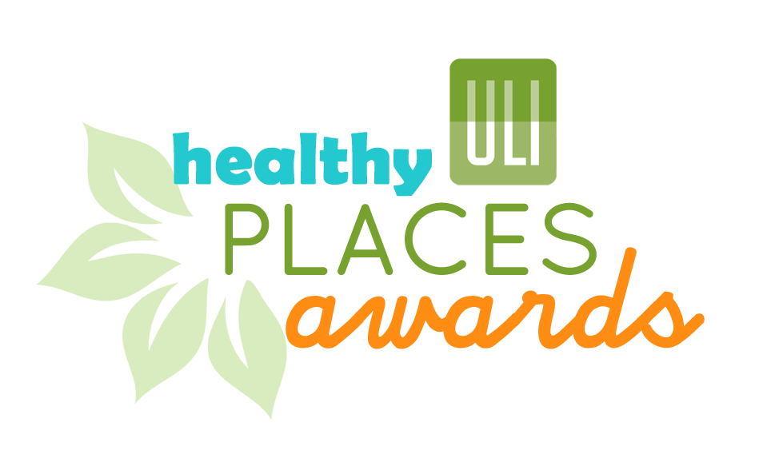
- Putting people first
- Empowering champions for health
- Energizing shared spaces
- Making healthy choices easy
- Ensuring equitable access
- Mixing it up
- Embracing unique character
- Promoting access to healthy food
- Making it active
- Recognizing the economic value
ULI Building Healthy Places Toolkit:
http://uli.org/research/centers-initiatives/building-healthy-places-initiative/building-healthy-places-toolkit/
The ULI Philippines Healthy Places Awards are open to the public and projects of all sizes. A nominal fee of PHP 4,700.00 (USD 100) would be collected for the application.
This activity is part of the inaugural ULI Philippines and Philippine Green Building Council Awards for Excellence in Sustainability and Health.
APPLICATION PROCESS & CHECKLIST
- Must be Nominated
Nomination Form must be completed to receive Application. Open to Public. Free to nominate.
Link: Healthy Places Awards - Nomination Form

- Fill out Application Form
- DESCRIPTION of the project (500-word maximum)
- NARRATIVE RESPONSE to the evaluation criteria (1,000-word maximum)
- IMAGES (high resolution jpg, 10 maximum)

- Submit to ULI Philippines / Philippine Green Building Council
Email: uliphilcouncil@gmail.com
Application Fee: PHP 4,700.00 + VAT ($100 USD) payable to Philippine Green Building Council
Account Name: PHILIPPINE GREEN BUILDING COUNCIL (PGBC) INC.
Bank / Branch: BANCO DE ORO – J.R. RIZAL MAKATI BRANCH
Peso Account Number: 140 112 944 Swift Code: BNORPHMM
Kindly attach deposit slip with the application submission or send check to the PhilGBC Office at: Unit G-4B, The NET One Center, 26th Street corner 3rd Avenue Bonifacio Global City, Taguig City 1634 Philippines.

IMPORTANT DATES
Nominations & Applications Open: April 15, 2016
Nominations & Applications Close: June 15, 2016
Announcement of Finalists: July 1, 2016
AWARDS NIGHT: July 14, 2016

Major Sponsors: Aon Insurance

Major Partners: Philippine Green Building Council & St. Luke’s Medical Center

The Urban Land Institute is a global non-profit education and research institute supported by its members. Founded in 1936, we now have more than 37,000 members worldwide, representing the entire spectrum of land use and real estate development disciplines working in private enterprise and public service. As a multidisciplinary real estate forum, ULI facilitates an open exchange of ideas, information, and experience among industry leaders and policy makers dedicated to creating better places.
APPLICATION FORM

Project Name:

Project Location/Address:

Project Website (if applicable):

Category: Residential Commercial/Office Institutional Other/Miscellaneous

Project Description:
Briefly describe the project as you would to a prospective client, a group of developers, or your financial partner. (Max. 500 words)

Evaluation Criteria
How does this submission respond to and support ULI’s Ten Principles of Building Healthy Places and ULI’s 21 Strategies under the Building Healthy Places Toolkit? (Max. 1000 words)
Link to the Ten Principles of Building Healthy Places
Link to the the Building Healthy Places Toolkit

Development Team
For each, please include the following information: name, title, company, city, province, contact info (phone or email):
Developer(s):
Owner(s) (if not same as developer):
Architect(s):
Engineer(s):
Debt/Equity participant(s):
Other(s): [counsel, contractors, consultants, community partnership partners, public sector participants]

Submitter:
Primary Contact (if different from submitter):
Contact Person’s Phone:
Contact Person’s Email:
Contact Person’s Address:

Authorization:
Authorization must be signed by the owner or developer or manager overseeing the project. Provide contact information here and sign below.
____________________________________

The undersigned attests that:
- ULI Philippines may use, reproduce, or make available for reproduction by other the information on this form (excluding financial information) and any supporting materials (including images) provided for the sole purposes of the Healthy Places Awards only.
- There is no pending or impending concerns with this project’s financial condition, or if, there are, that they will be disclosed.
- Signed party (he/she) has the full power and authority to provide this information and to grant these rights and permissions.

Images
Please package 10 images with your submission via email. The first image should a locator map showing the project’s location relative to the metropolitan area. The second image should be a project site plan. Please number each image and properly credit the photographer, artist or designer of the image. Keep in mind that the project images are instrumental in helping the jury understand your entry. In addition, they may be used to make a video to be presented in the awards ceremony. Thus, the higher the quality, the better.

Submission
Images and application form may be submitted via email to uliphilcouncil@gmail.com (can be submitted in batches or via WeTransfer, etc.)
Payment for the submission will be made payable to Philippine Green Building Council (Co-Organizer of Awards) through check or bank deposit (see above for bank details). Checks and official receipts may be collected at the Philippine Green Building Office at Unit G-4B, The NET One Center, 26th Street corner 3rd Avenue Bonifacio Global City, Taguig City 1634 Philippines.

